Work Plan
Implementation:

Bisphenol A and its Alternatives in Food Packaging

October 2019

Prepared by

Introduction
The Safer Consumer Products regulations define the process and criteria used by the Department of Toxic Substances Control (DTSC) to evaluate consumer products for possible designation as Priority Products. In that process, DTSC issues a Priority Product Work Plan (Work Plan) identifying the product categories to evaluate over a three-year period. DTSC then considers the product categories through the lens of the Work Plan’s stated policy goals (Figure 1).
Since issuing the 2018-2020 Work Plan,¹ DTSC has conducted a review of product categories, chemicals, and chemical classes that align with our policy goals. This document summarizes our preliminary findings on food packaging containing bisphenol A (BPA) and its alternatives, and describes our concerns. Publication of this document signals the beginning of a dialogue with interested stakeholders, including manufacturers, nonprofit organizations, governments, and academia, to inform DTSC on the potential listing of specific consumer products containing BPA and its alternatives as one or more Priority Products subject to the requirements of the Safer Consumer Products regulations.
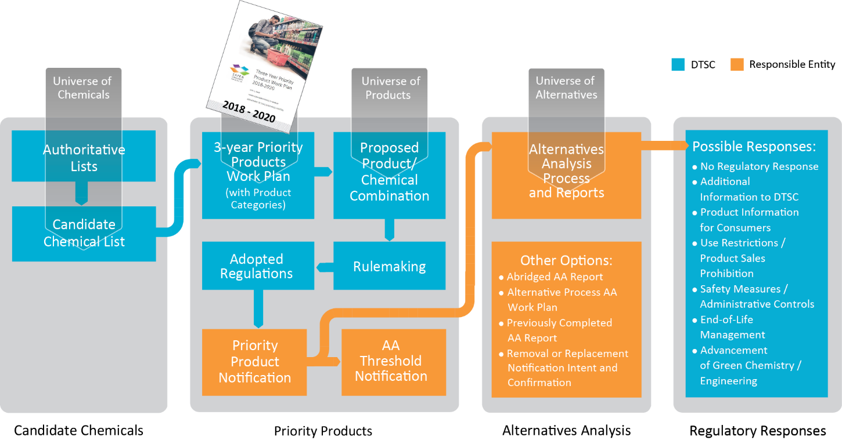
Figure 1. An overview of the Safer Consumer Products regulations.

Background
DTSC’s 2018-2020 Priority Product Work Plan¹ adopted policy goals to guide DTSC in prioritizing Priority Products. In considering the product categories in the Work Plan and our policy goals, DTSC identified BPA, as well as some of its analogues and alternatives, as Candidate Chemicals that may warrant further research regarding their use in food packaging products. This research would address two of the policy goals outlined in the Work Plan:
- to protect children from exposure to harmful chemicals, especially carcinogens, mutagens, reproductive toxicants, neurotoxicants, developmental toxicants, and endocrine disruptors; and
- to protect Californians from chemicals that migrate into food from food packaging.
BPA is one of the most studied environmental contaminants in the world and has been classified as an endocrine disrupting chemical due to its ability to disrupt estrogen, androgen, and thyroid-hormone mediated biological pathways. One of the major uses of BPA is to manufacture epoxy-based resins that coat the interior of aluminum and steel food and beverage cans. BPA may also be used in other food packaging liners, such as jar lids and bottle caps (collectively referred to as “lids” within this document). Liners protect the metal packaging from corrosion, act as inert barriers to a wide variety of food types, and are sufficiently flexible and adhesive for use during can/lid manufacturing processes. It has been well documented that, under certain conditions, BPA is capable of migrating out of these liners and into food items, leading to the potential for subsequent dietary exposure in humans.
Public awareness concerning the risks associated with BPA exposure has created market pressure to remove it from food packaging applications. Many food packaging manufacturers have proactively removed BPA from their products, even though the U.S. Food and Drug Administration considers its use in food packaging materials as safe. However, other bisphenols, such as bisphenol F (BPF), bisphenol S (BPS), and bisphenol AF (BPAF), which are all on DTSC’s Candidate Chemical List, may be used as drop-in replacements for BPA, and many of these compounds exhibit similar endocrine disrupting properties as BPA. Non-bisphenol chemicals may also be used to manufacture can and lid liners, such as glycidyl methacrylate, a possible BPA replacement. Glycidyl methacrylate has been classified as a Category 1B carcinogen and reproductive toxicant by the European Chemicals Agency (ECHA), and is also on DTSC’s Candidate Chemical List. At this time, the prevalence and application of BPA and its chemical alternatives that manufacturers may be using in liners for food and beverage cans and lids are unknown to DTSC.
DTSC is requesting additional information from stakeholders about the specific use of bisphenols in food packaging products, the adverse impacts associated with the life cycle of these products, and the availability and feasibility of alternatives. Please see the Questions to Stakeholders section below.

Preliminary Screening Results
Hazard Traits
The hazard traits of BPA are well defined in the scientific literature and include developmental toxicity, reproductive toxicity, endocrine toxicity, immunotoxicity, and neurodevelopmental toxicity. BPA has been robustly studied in animal models, in vitro models, and in human epidemiological cohorts^{2,3}. Many associations between BPA exposure and adverse perinatal, childhood, and adult health outcomes have been shown. For example, many published scientific studies have shown BPA to be associated with changes in neuronal development^{4–7}, decreased fertility⁸, endocrine changes^{9–11}, and metabolic^{12,13}, cardiovascular¹⁴, and immunological diseases¹⁵. Numerous studies also suggest that BPA exposure has the potential to cause adverse behavioral and developmental effects in children¹⁶. Due to the endocrine disrupting properties of BPA, exposure in fetuses, infants, and children, as well as women of childbearing age, is of special concern. It is well documented that these groups may have an increased susceptibility to certain toxicants during development, and so exposure to these types of chemicals should be limited.
Structural analogues of BPA, such as BPF and BPS, have also been shown to be endocrine disrupting chemicals and to be as hormonally active as BPA, indicating that these are not suitable chemical replacements for BPA in food packaging applications ^{19,20}.
Exposure and Presence in Products
Diet is the main route of BPA exposure in humans. BPA may migrate out of can and lid liners into food and beverages, leading to dietary exposures. Many variables contribute to the migration rates of BPA, such as food and beverage pH, storage time, temperature, and fat content. Because epoxy-based liners represent such a large portion of the food packaging landscape, exposure to these chemicals is a potential problem for a significant proportion of the general population.
Food and beverage cans are widely available in California. In 2011, the Can Manufacturers Institute estimated that 98 percent of Americans have canned foods in their kitchens, with an average of 24 cans per household²¹. A 2012 survey based on a sample of 1,017 U.S. adults found that 90 percent of Americans depend to some extent on canned fruits and vegetables for part of their produce intake. Those who depend on food assistance programs may rely on canned fruits and vegetables for a significant portion of their produce consumption. The survey found that Americans consume 5.5 cans of fruits and vegetables on average per week, but those receiving food assistance through the Supplemental Nutrition Assistance Program and Women, Infant and Children programs consume an average of 7.1 cans of fruit and vegetables per week²². This suggests that individuals of lower socioeconomic status may have higher rates of exposure to BPA and its alternatives. As a result, this product-chemical combination addresses widespread exposure to the general population of California, as well as exposure within sensitive subpopulations (women and children).

Next Steps
Public Engagement
DTSC is asking stakeholders to address the questions listed in Themes 1-3 below. A public comment period will begin on November 19, 2019. Written comments can be submitted via the online information management system CalSAFER. The comment period will close on December 19, 2019, at 11:59 p.m. In addition, DTSC will hold a public workshop with stakeholders and invited participants on November 19, 2019. Further details about this workshop will be available on our Workshops and Events Webpage. This stakeholder engagement process will help inform additional research that may result in the proposal of one or more Priority Products. Please monitor our Priority Products Work Plan Implementation webpage for updates on this topic.

Questions to Stakeholders
Theme 1. Manufacturing
- Who manufacturers food packaging liners in the United States?
- Who manufactures food packaging that contains BPA and/or its alternatives?
- Are there any food packaging manufacturers in California that make products with BPA and/or its alternatives?
- What chemicals are currently used to manufacture can and lid liners in food packaging?
- What type of liners are California manufacturers using (epoxy-based, oleoresin, vinyl, phenolic, acrylic, polyester, polyolefins), and how do they differ by product subtype (food cans, beverage cans, jar lids, bottle caps)?
Theme 2. Market Presence
- How much food packaging containing BPA and/or its alternatives, and what types, are on the market in California and nationally?
- Which manufacturers supply the liners used in food and beverage cans sold in California?
- Do you have any specific data on the market presence of food packaging containing BPA and/or its alternatives and the supply chain?

Theme 3. Supply Chain
- Who manufactures and supplies the BPA and/or its alternatives-containing starting materials (e.g., epoxy-based liners) to food packaging manufacturers?
- Are there intermediaries (converters) who take the liner materials (e.g., liner materials) and assemble them into a more final food package product (ex. food or beverage can), and who are they?
- Are there manufacturers of food packaging liners that contain BPA and/or its alternatives located outside the United States, and if so who are they and where are they located? Are these products imported to the United States and/or sold in California?

References
1. DTSC, (Department of Toxic Substances Control). 2018-2020 Priority Product Work Plan. Available at: https://dtsc.ca.gov/scp/priority-product-work-plan/. (Accessed: 7th August 2019)
2. Rubin, B. S. Bisphenol A: An endocrine disruptor with widespread exposure and multiple effects. The Journal of Steroid Biochemistry and Molecular Biology 127, 27–34 (2011).
3. Rochester, J. R., Bolden, A. L. & Kwiatkowski, C. F. Prenatal exposure to bisphenol A and hyperactivity in children: a systematic review and meta-analysis. Environ Int 114, 343–356 (2018).
4. Perera, F. et al. Prenatal bisphenol a exposure and child behavior in an inner-city cohort. Environ. Health Perspect. 120, 1190–1194 (2012).
5. Hong, S.-B. et al. Bisphenol A in relation to behavior and learning of school-age children. J Child Psychol Psychiatry 54, 890–899 (2013).
6. Braun, J. M. et al. Impact of Early-Life Bisphenol A Exposure on Behavior and Executive Function in Children. PEDIATRICS 128, 873–882 (2011).
7. Ejaredar, M., Lee, Y., Roberts, D. J., Sauve, R. & Dewey, D. Bisphenol A exposure and children’s behavior: A systematic review. Journal of Exposure Science & Environmental Epidemiology 27, 175–183 (2017).
8. Ziv-Gal, A. & Flaws, J. A. Evidence for bisphenol A-induced female infertility: a review (2007-2016). Fertil. Steril. 106, 827–856 (2016).
9. Wetherill, Y. B. et al. In vitro molecular mechanisms of bisphenol A action. Reprod. Toxicol. 24, 178–198 (2007).
10. Teng, C. et al. Bisphenol A affects androgen receptor function via multiple mechanisms. Chem. Biol. Interact. 203, 556–564 (2013).
11. MacKay, H. & Abizaid, A. A plurality of molecular targets: The receptor ecosystem for bisphenol-A (BPA). Horm Behav 101, 59–67 (2018).
12. Alonso-Magdalena, P., Rivera, F. J. & Guerrero-Bosagna, C. Bisphenol-A and metabolic diseases: epigenetic, developmental and transgenerational basis. Environ Epigenet 2, dvw022 (2016).
13. Hugo, E. R. et al. Bisphenol A at Environmentally Relevant Doses Inhibits Adiponectin Release from Human Adipose Tissue Explants and Adipocytes. Environmental Health Perspectives 116, 1642–1647 (2008).
14. Gao, X. & Wang, H.-S. Impact of bisphenol a on the cardiovascular system - epidemiological and experimental evidence and molecular mechanisms. Int J Environ Res Public Health 11, 8399–8413 (2014).
15. Hessel, E. Assessment of recent developmental immunotoxicity studies with bisphenol A in the context of the 2015 EFSA t-TDI. - PubMed - NCBI. (2016). Available at: https://www.ncbi.nlm.nih.gov/pubmed/27352639. (Accessed: 7th February 2019)
16. Rochester, J. R. Bisphenol A and human health: A review of the literature. Reproductive Toxicology 42, 132–155 (2013).
17. Wolstenholme, J. T., Rissman, E. F. & Connelly, J. J. The role of Bisphenol A in shaping the brain, epigenome and behavior. Horm Behav 59, 296–305 (2011).
18. Prins, G. S., Patisaul, H. B., Belcher, S. M. & Vandenberg, L. N. CLARITY-BPA academic laboratory studies identify consistent low-dose Bisphenol A effects on multiple organ systems. Basic Clin. Pharmacol. Toxicol. (2018). doi:10.1111/bcpt.13125
19. Rochester, J. R. & Bolden, A. L. Bisphenol S and F: A Systematic Review and Comparison of the Hormonal Activity of Bisphenol A Substitutes. Environ Health Perspect 123, 643–650 (2015).
20. Pelch, K. et al. A scoping review of the health and toxicological activity of bisphenol A (BPA) structural analogues and functional alternatives. Toxicology 424, 152235 (2019).
21. CMI. Canned Foods Stocked In 98 Percent Of Americans’ Kitchens. (2013). Available at: https://www.prnewswire.com/news-releases/canned-foods-stocked-in-98-percent-of-americans-kitchens-215071531.html. (Accessed: 14th August 2019)
22. CMI. New Research Confirms Americans Depend on Canned Fruits and Vegetables | Can Manufacturers Institute. (2012). Available at: http://www.cancentral.com/media/news/new-research-confirms-americans-depend-canned-fruits-and-vegetables. (Accessed: 14th August 2019)

DTSC webpage: What are the Safer Consumer Products Regulations?

