information call-in calsafer user guide

Department of Toxic Substances Control
Safer Consumer Products Program

Table of Contents
A. How to Register on CalSAFER 2
B. How to Sign in to your CalSAFER account 4
C. How to Submit to an Information Call-in on CalSAFER 4
Step One - Instructions 8
Step Two – Entity 9
Step Three – Information Call-in 13
Step Four – Comment 15
Step Five – Supporting Documents 16
Step Six – Trade Secret Claims 18
Step Seven – Review 20
Step Eight – Certification and Submit 21
DTSC’s Privacy Policy and Terms Of Use 26

A. How to Register on CalSAFER
- If you do not have an account on CalSAFER, you need to register and create an account prior submitting to an information call-in.

- If you already have a CalSAFER account, you can skip the registration step of this document (Part A) and use your credentials to “sign in” to your CalSAFER account. To Sign in to your CalSAFER account, please follow the instructions at Part B of this document.

To register on CalSAFER, please follow these steps:
1. Go to CalSAFER home page at https://calsafer.dtsc.ca.gov/

2. Click on the “Register” tab on the top right (see image below).
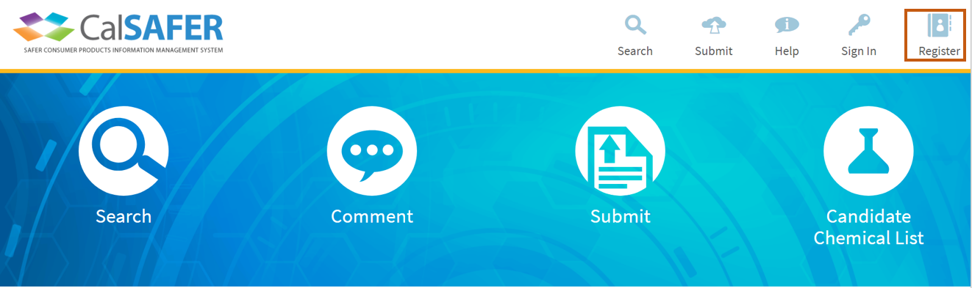
3. a. Fill in your information on the registration page.

b. Check the “Register an Entity” box on the registration page to register your company information (see image below).

You must fill in all the fields. After you fill in all the fields including your company information:

c. Read and check the box for “DTSC’s privacy and terms of use” (see image below).

d. Click the “Register” button at the bottom of the registration page (see image below).
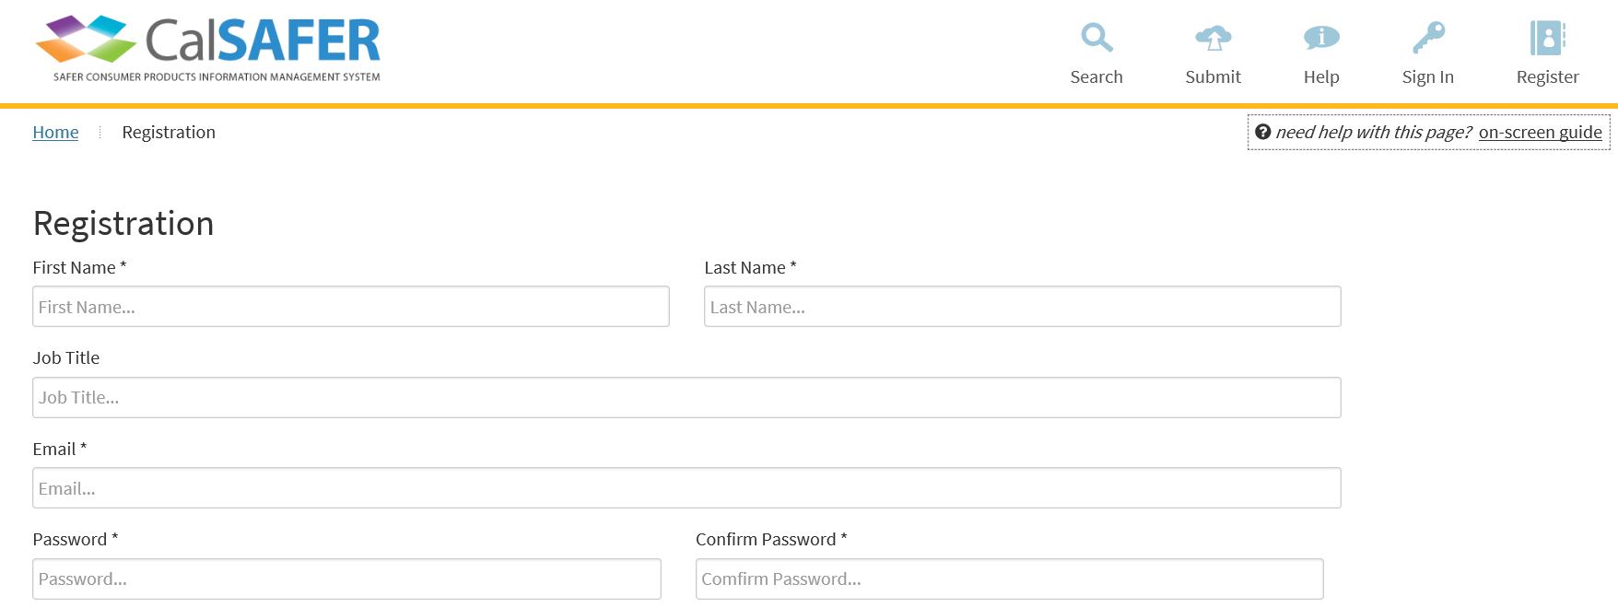
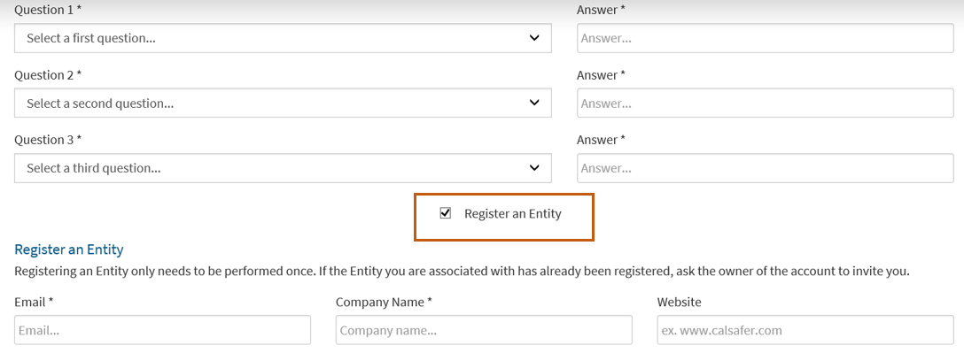
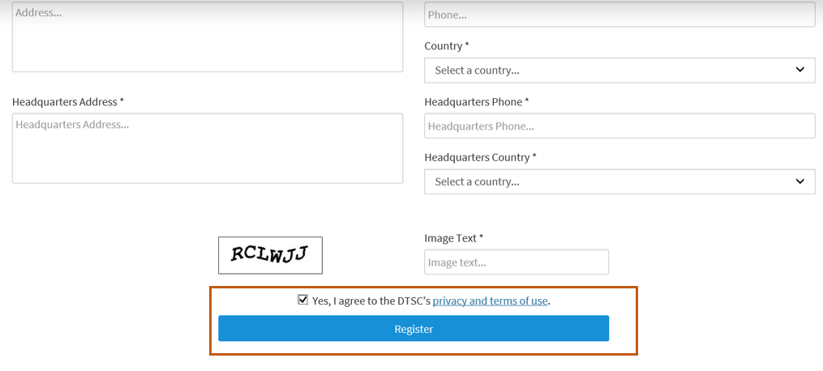
4. After completing step 3 (clicking register), CalSAFER will send you an email to verify your account.
5. Click on the link sent from CalSAFER to confirm your registration (see image below).
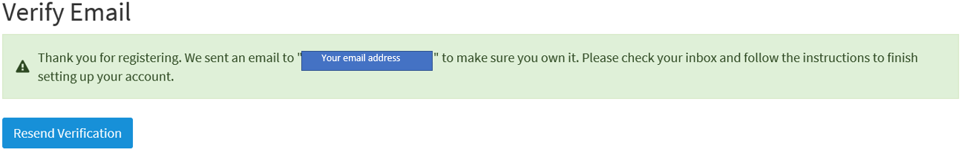
5. After you verify your account, follow Part B of this document to sign in to your CalSAFER account.

B. How to Sign in to your CalSAFER account
If you have a CalSAFER account, you can use your credentials to sign in to CalSAFER.

To sign in to CalSAFER, please follow these steps:
1. Go to CalSAFER home page at https://calsafer.dtsc.ca.gov/
2. Click on the “Sign In” tab on the top right (see image below).
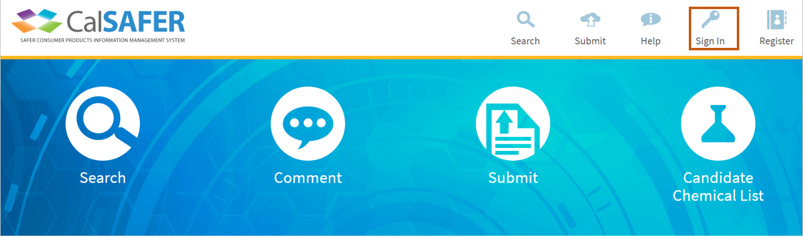
3. After you sign in to your CalSAFER account, follow Part C of this document to submit to an information call-in.

C. How to Submit to an Information Call-in on CalSAFER
You can submit to an information call in via two different routes on CalSAFER:
Route 1.
1. Click on the “Submit” bubble icon on CalSAFER home page (see image below).
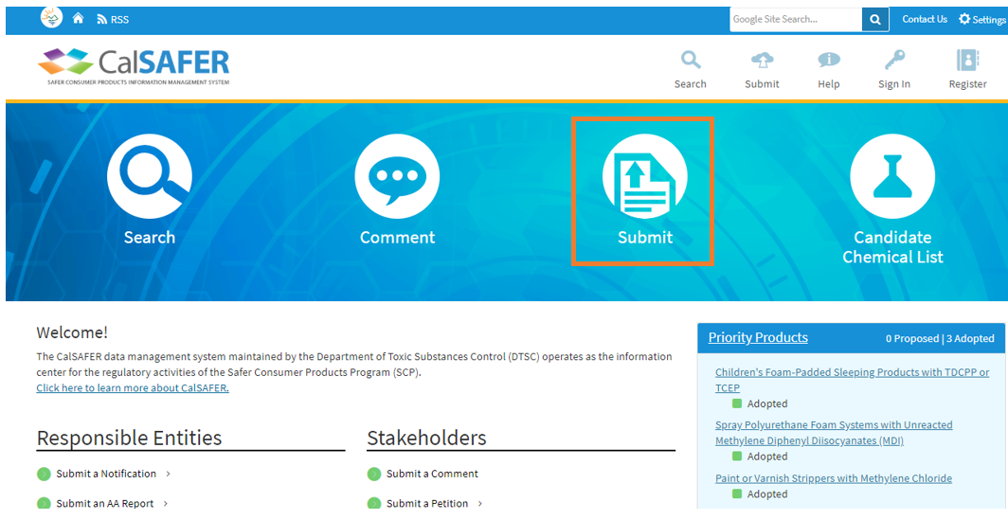

2. Click on the “Start” button for “Information Call-in” under Activities (see image below).
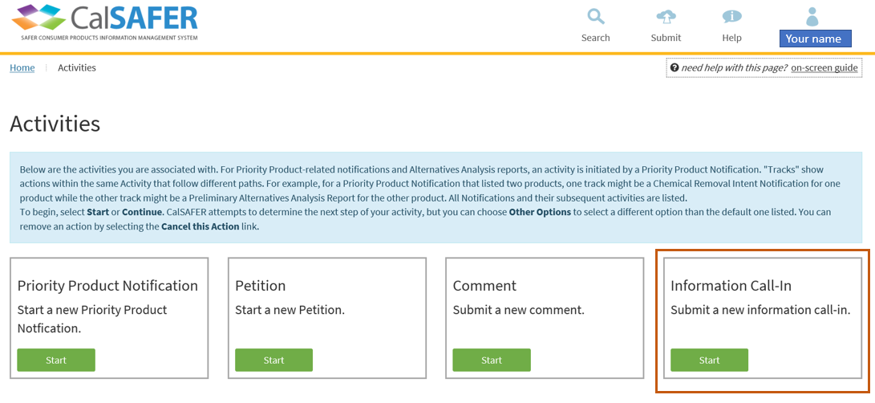
OR;
Route 2.
1. Click on the “Submit” button on the top right on CalSAFER home page (see image below).
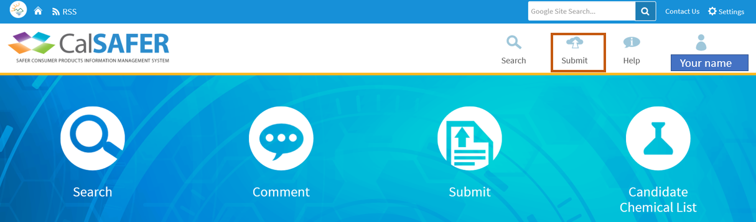
2. Once clicked, a dropdown box will appear. On the left side of the dropdown box is a link to the information call-ins.
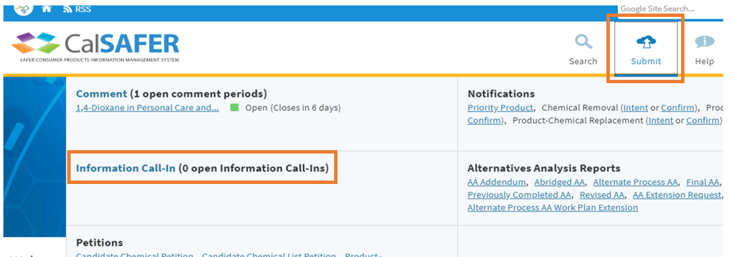
3. Click on the Information Call-in package you want to submit under “Information Call-in” (see image below).
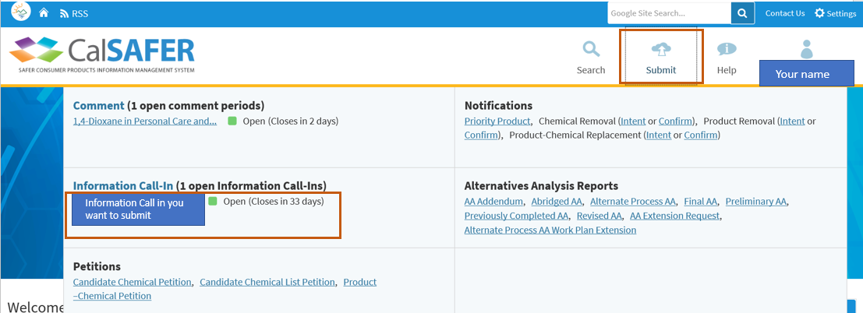
4. This will open the information call-in package you want to submit.
5. To see the information requested for this information call-in, click on the “Supporting Documents” on the right (see image below).
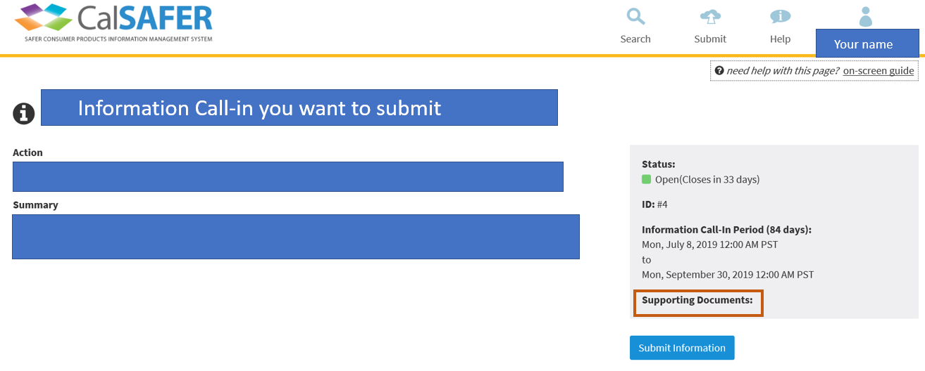
6. To submit to this information call-in, click on the blue “Submit Information” button on the right (see image below).
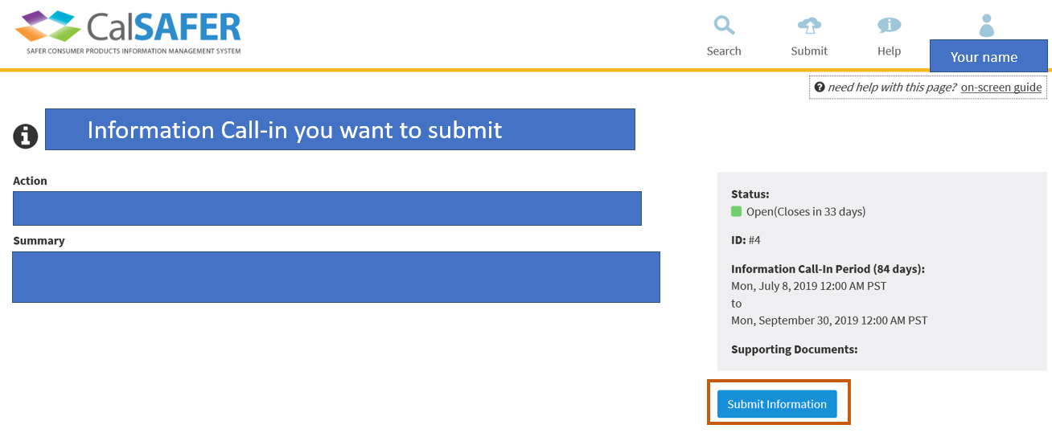
Routes 1 and 2 will both lead you to the Information Call-In Workflow (see image below).
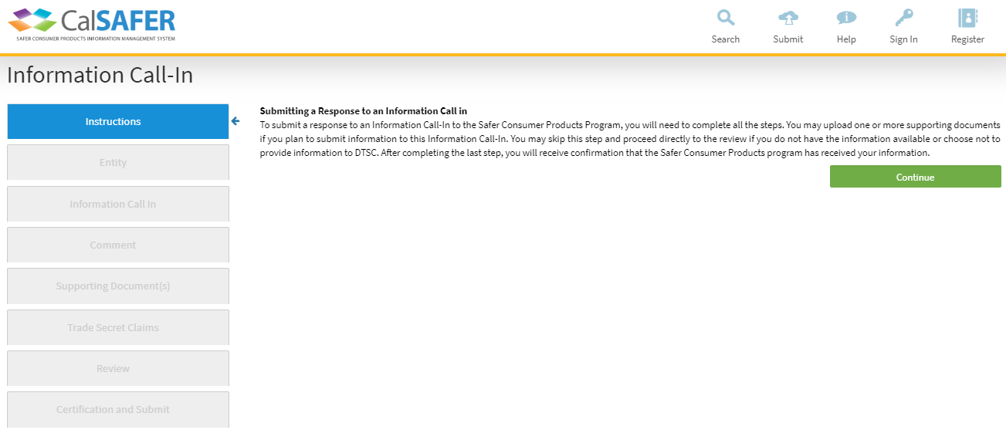
Information Call-in Workflow
Information Call-in workflow has a total of eight (8) steps. The steps are:
1. Instruction,
2. Entity,
3. Information Call-in,
4. Comment,
5. Supporting Document(s),
6. Trade Secret Claims,
7. Review, and
8. Certification and Submit.
The dark blue highlighted step is the current step you are on.

Step One - Instructions
The Instruction Step provides instructions on how to submit a response to an information call-in.
1. Read the instructions at this step.
2. Click on the green “Continue” button to go to the next step (see image below).
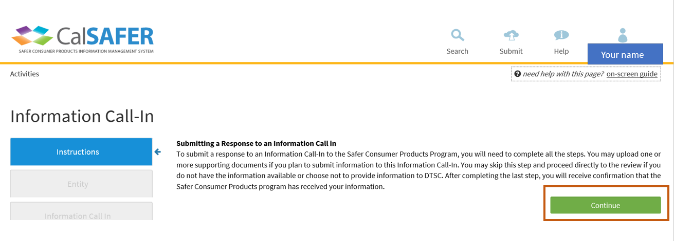

Step Two – Entity
You can add entity information to the information call-in you are submitting to at this step.
You may click on grey information “i” button next to “Entity” to review the definition of an entity (see image below).
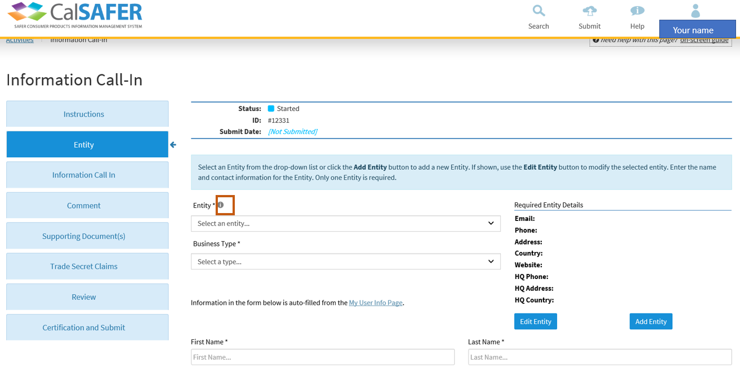
- If you registered your entity at the registration step (Part A of this document), then follow the steps below:
1. Click on the “Entity” dropdown list (see image below).
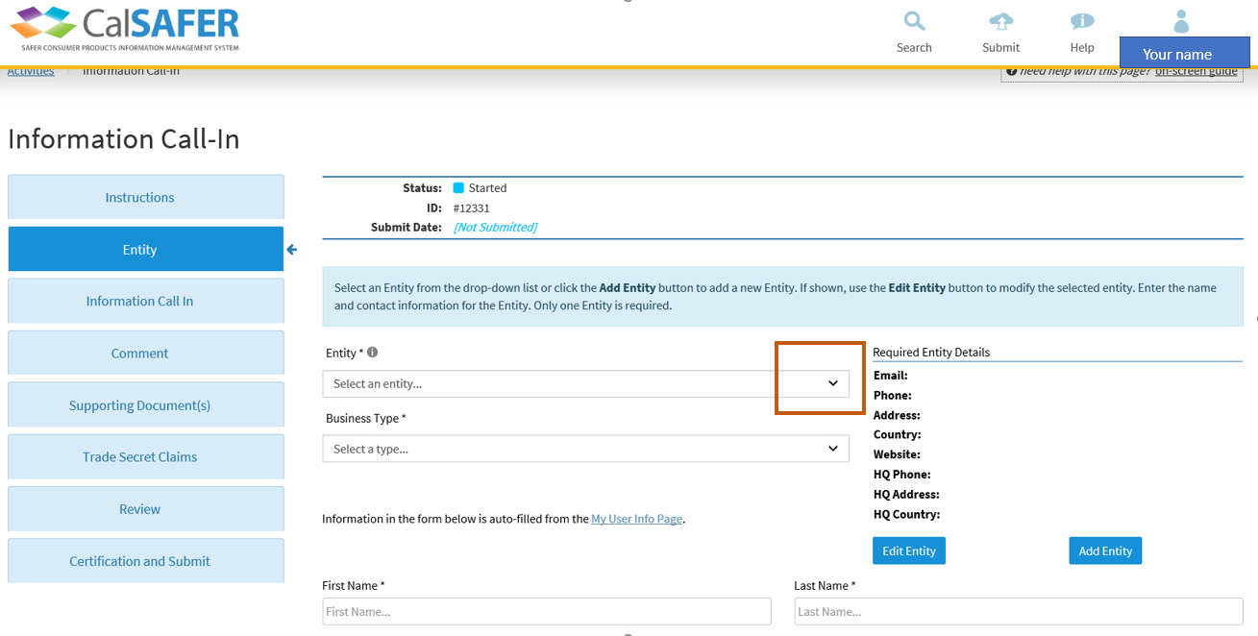
2. Select your entity from the dropdown list. Selecting an existing entity from the dropdown list will auto populate the fields for your entity details.
3. If there are missing fields or any field has incorrect information for your entity, click on “Edit Entity” button to edit the entity information (see image below).
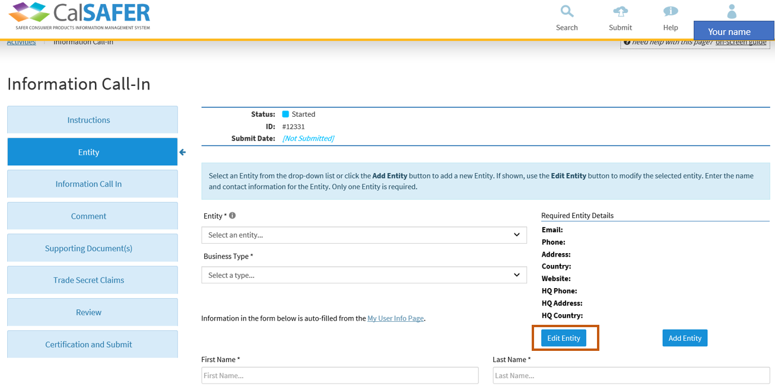
- If you haven’t registered your entity at the registration step (Part A of this document), then you need to register your entity at this step.
To add an entity, please follow the steps below:
1. Click on the blue “Add Entity” button to enter your entity details (see image below). You must fill in all the fields with an asterisk. Validation error messages will pop up if you do not fill in all the fields.
2. After you fill in your entity information, click on the “Add” button.
3. If you need to change your entity details, click on the blue “Edit Entity” button (see image below). After you make changes to your entity details, click the “Save” button.
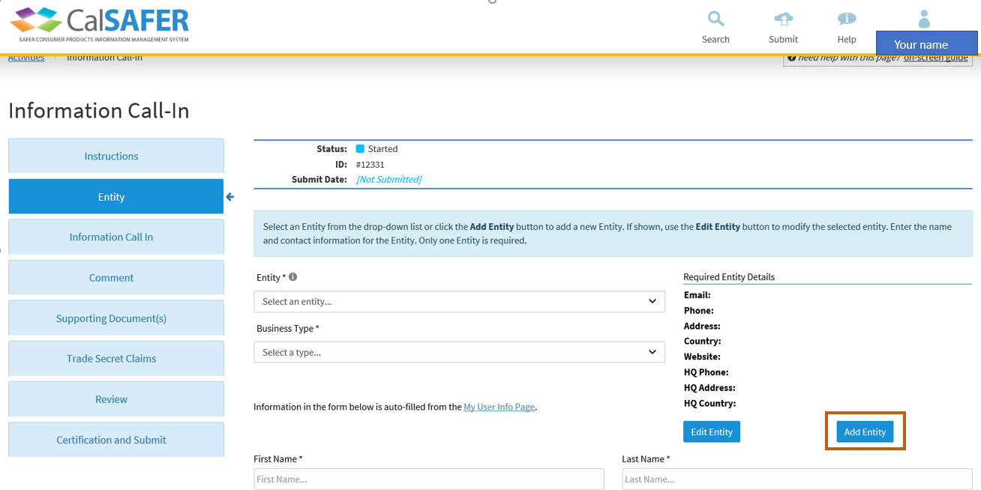

- After you filled the required entity fields, follow the steps below:
1. Click on the “Business Type” dropdown list and select the business type for your entity (see image below)
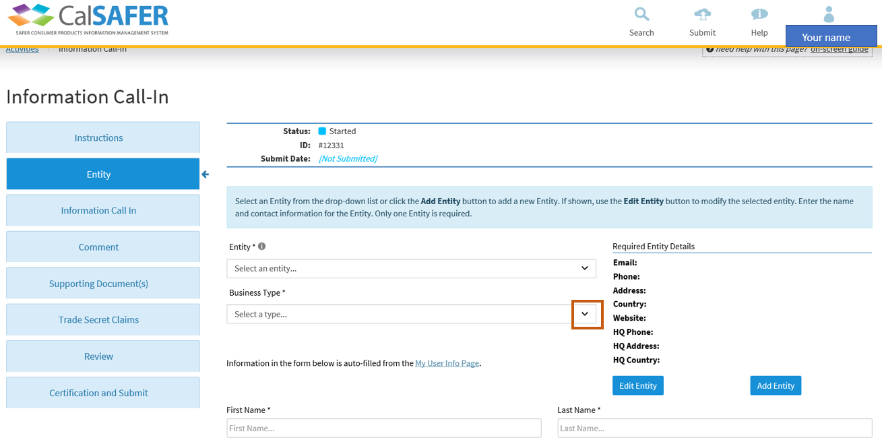
2. Fill in all the remaining fields at this step.
3. Click the green “Save and Continue” to go to the next step (see image below).
4. If you want to save your information and continue your submission at a later time, click the blue “Save and Exit” button (see image below).
5. If you want to go to the previous step, click on the blue “Previous Step” (see image below).
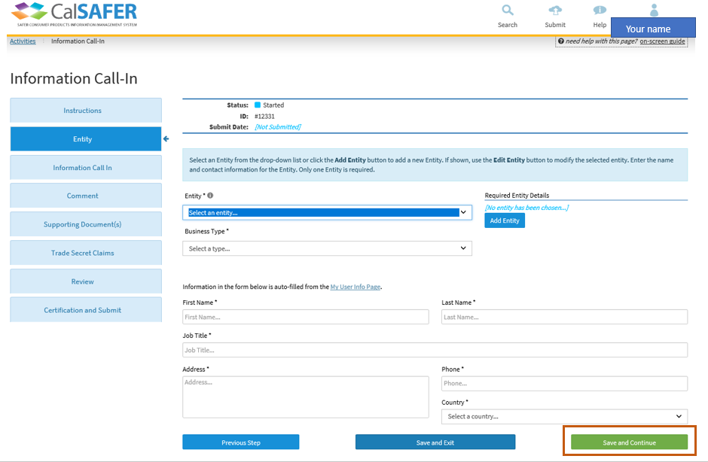

Step Three – Information Call-in
You can select the information call-in package you are submitting to at this step.
- If you started the information call-in by selecting the information call-in package (Route 2):

1. Information call-in package will be pre-selected by the system. Make sure this is the correct information call-in package you want to submit to.

2. You may click on the “Supporting Documents” button to review the information requested for this call-in (see image below).

3. Click on the green “Save and Continue” button to go to the next step (see image below).

- If the information call-in package is not pre-selected by the system:

1. Click on the “Information Call-In package” dropdown list and select the information call-in package you want to submit to (see image below).
2. You may click on the “Supporting Documents” button to review the information requested for this call-in (see image below).

3. Click on the green “Save and Continue” button to go to the next step (see image below).

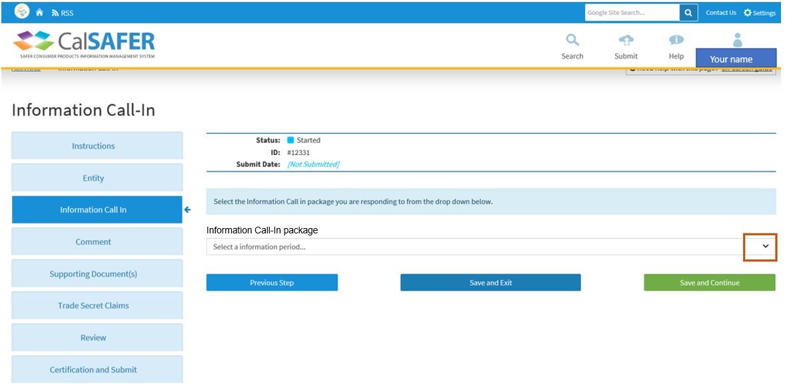
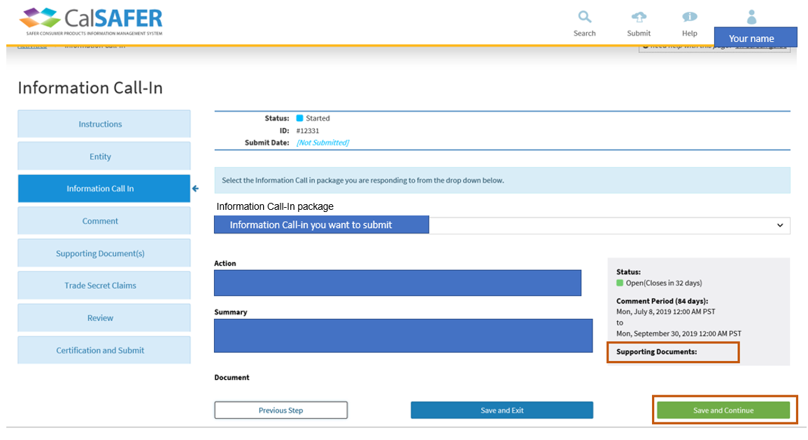

Step Four – Comment
You must fill in the comment field to justify your response to this call-in at this step. You cannot leave the comment field blank. You are required to fill in the comment field with one of the following responses:
- If you are providing the requested information, enter details regarding the information you are providing in the supporting documents in the next step (Step 5-Supporting Documents) such as information source, assumptions, etc.

OR;

- If the information requested is not available (partially or at all) to your entity, you must justify with a response that you do not have or cannot generate the requested information.

OR;

- If the requested information is available to your entity, but you are not going to provide the requested information, provide a justification with your response in the comment field.

1. You must put one of the three responses described above in the comment field (see image below).

2. Click on the green “Save and Continue” button to go to the next step (see image below).
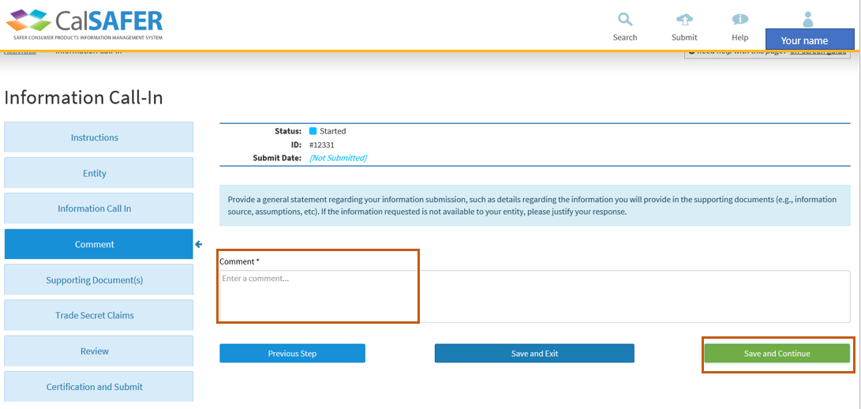

Step Five – Supporting Documents
You can submit information to the information call-in package you want to submit at this step. The information must be submitted via document upload.
1. Click on the blue “Browse” button to upload a document (see image below). The document must be in PDF or Excel (.xls or .xlsx) file format. The file size limit is 25MB per file. If you try to upload a file format other than PDF or Excel an error message will pop up to it will direct you to upload the document with the allowed file formats.
2. Enter a name for your document at the “Document Title” field (see image below).
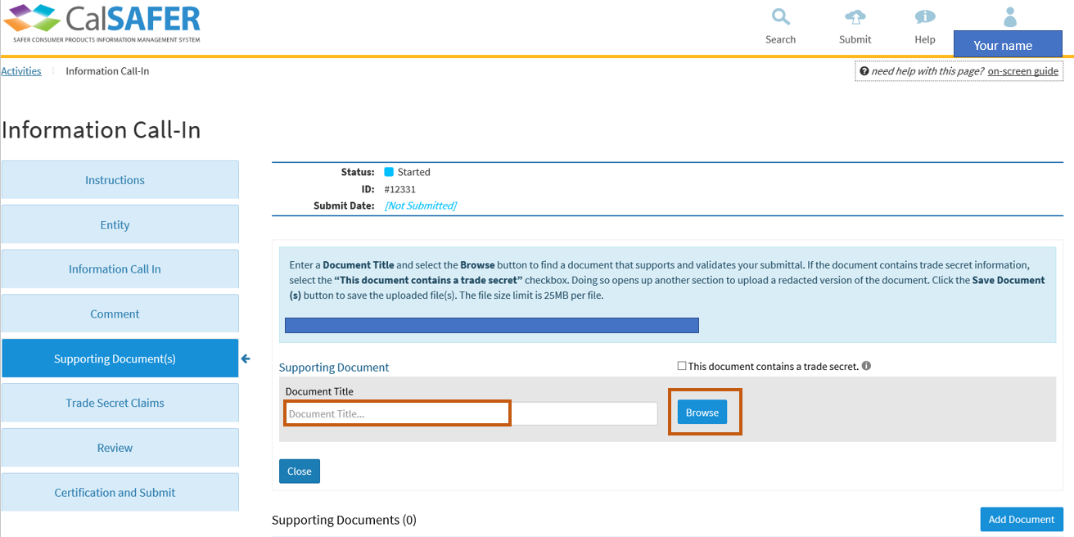
3. If the document contains a trade secret, click on the “This document contains a trade secret” checkbox. Doing so will open another section to upload a redacted version of the trade secret document. Upload the redacted version of the document and enter a name for the redacted document in the “Document Title” field and click on the “Save Documents” button (see image below).
4. If the document does not contain a trade secret, click on the “Save Documents” button (see image below).
- If the Date Uploaded status is “Not yet uploaded”, you must click on the “Save Documents” button before the file is uploaded.
- Once you click on the “Save Documents” button, a confirmation will popup indicating your documents successfully uploaded.
- You may add more documents or delete or replace a document you uploaded. Follow the steps below to add, delete, or replace documents.
5. If you want to add more documents, click on the “Add Document” button and repeat the steps described above (see image below).
6. If you uploaded an incorrect document and would like to delete that document, click on the “Delete” button next to the document you want to delete (see image below).
7. After you complete uploading documents, click on the green “Save and Continue” button to go to the next step (see image below).
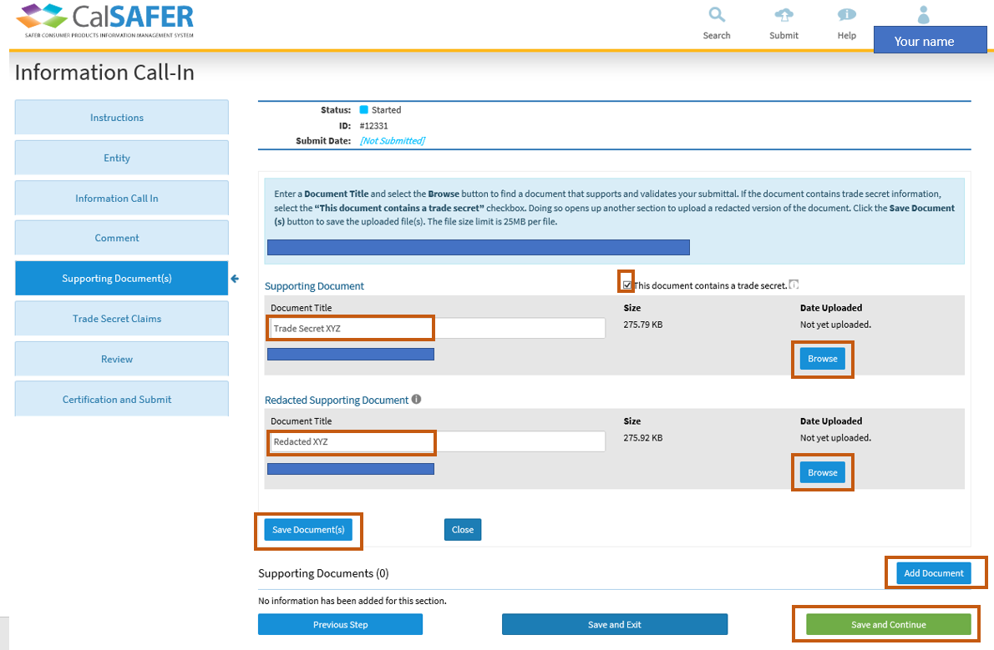
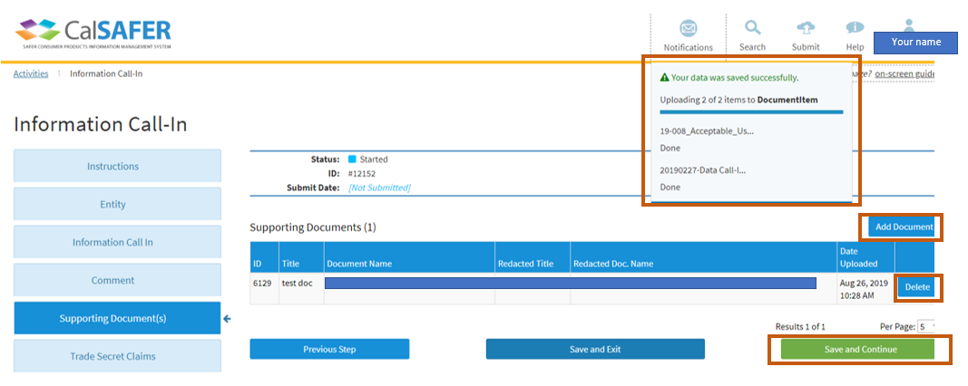
8. To view the files you uploaded, click on the “Supporting Document(s)” step on the left (see image below).
9. If you want to replace a document, click on the “Replace File” button next to that document you want to replace. Follow the steps described above to upload the replacement document.
10. After you review your documents, click on the green “Save and Continue” button to go to the next step (see image below).
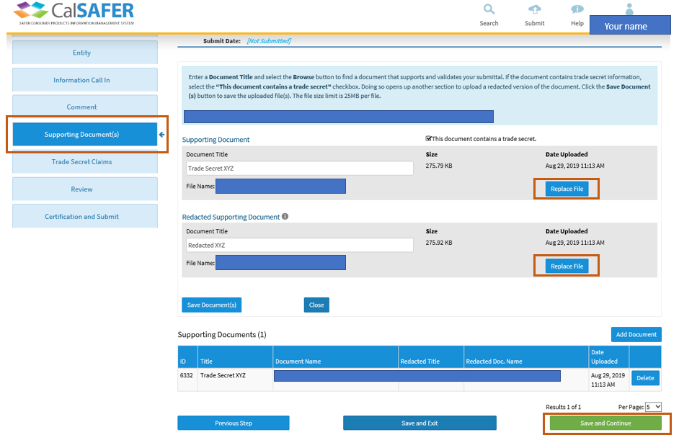

Step Six – Trade Secret Claims
If you are submitting a document that contains trade secret, then you need to answer all the questions at this section to justify your trade secret claim.
1. Click on the dropdown next to “Documents” to select the document you are submitting with the trade secret claim (see image below).
2. Type in a name for your document with trade secret in the “Name of Claim” field (see image below).
3. There are 10 questions you need to answer to justify your trade secret claim. Answer all 10 questions to justify your trade secret claim. If you leave any of the questions blank, the system will generate an error message and your trade secret claim justification will be marked as incomplete.
4. Click on the blue “Save Trade Secret Claim” button to save your trade secret claim for the document you are submitting with the trade secret (see image below).
5. Click on the green “Save and Continue” button to go to the next step (see image below).
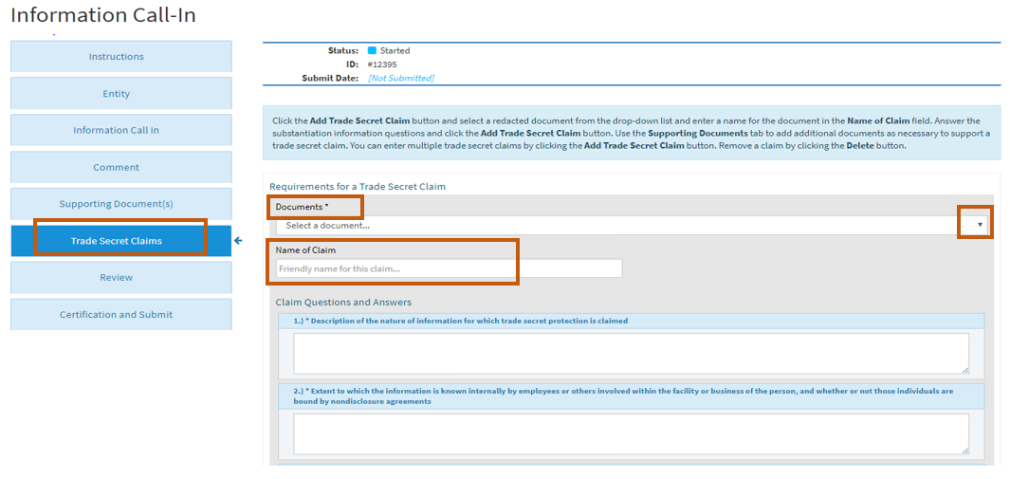
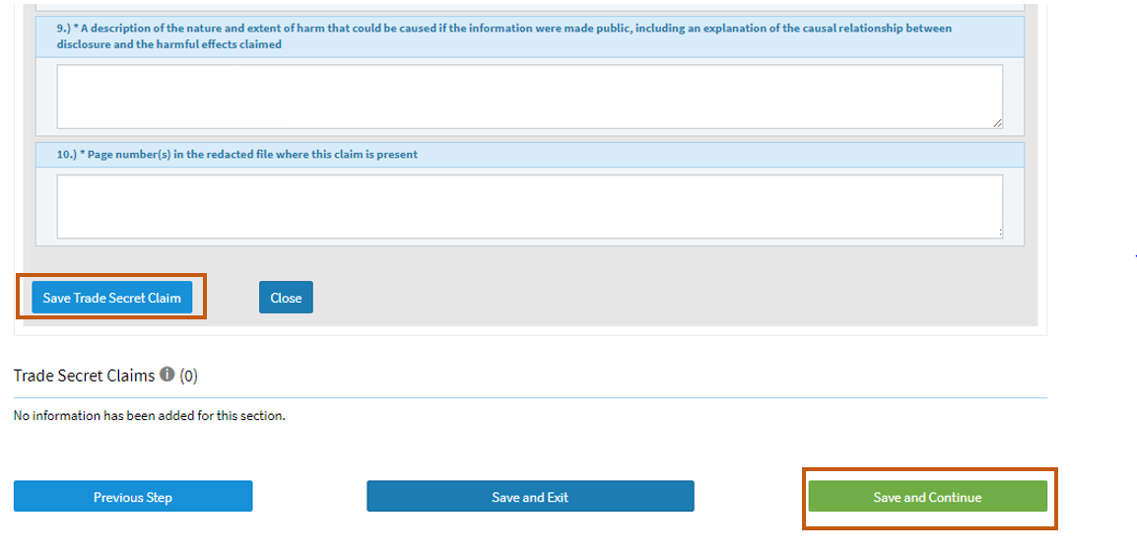

Step Seven – Review
You can review your information prior submitting to an information call-in at this step.
- If there is missing information, the step that has the missing information will be highlighted in red (see image below). Red font text will also appear where information is missing or where there are other errors at the review step fields.

For example: Image below shows that “Information Call-in” step has missing information. Red text will also indicate where the errors are at that step at the review step. For instance, “Information Periods” is not selected and this is a required field also highlighted in red text at the review step (see image below).

If any step has missing information, do the following:

1. Click on the step(s) on the left that are highlighted in red and fill in the missing information and click “Save and Continue”.

2. Make sure to scroll down to the bottom of the page at the “Review” step and identify all the errors.
3. Once you identified and fixed all the errors in all the red higlighted steps, click “Save and Continue” at the bottom of the page to go to the next step.
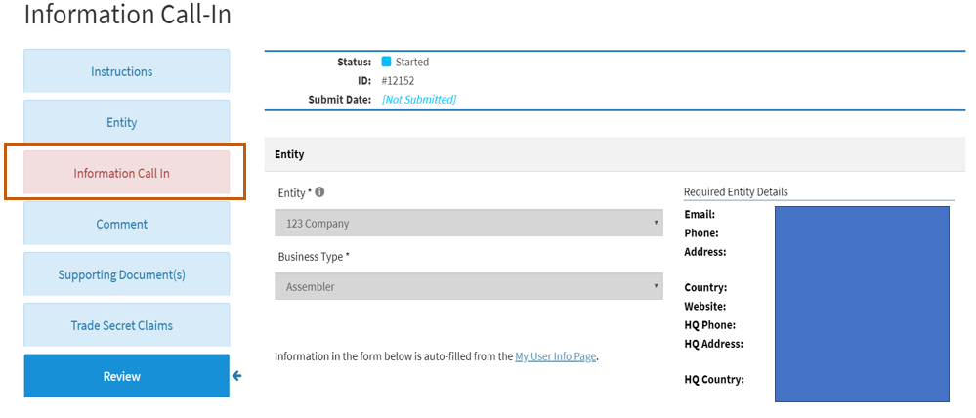
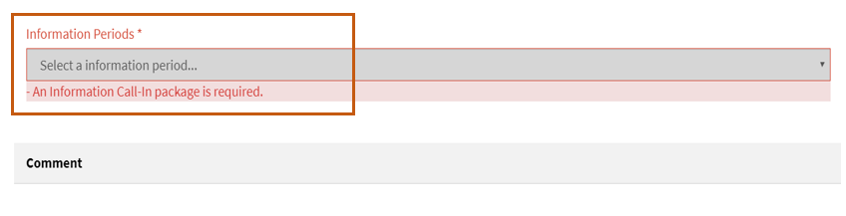
- If you do not see any red highligthed text at the “Review Step”, that means all the required fields have information. To continue, follow the steps below:
1. Review your information and make sure all the fields are correct. If you need to edit any field, go to the appropriate step and make edits as needed.
2. Make sure you scroll down at the bottom of the “Review” step to check all the fields have correct information.
3. Click “Save and Continue” at the bottom of the page to go to the next step.
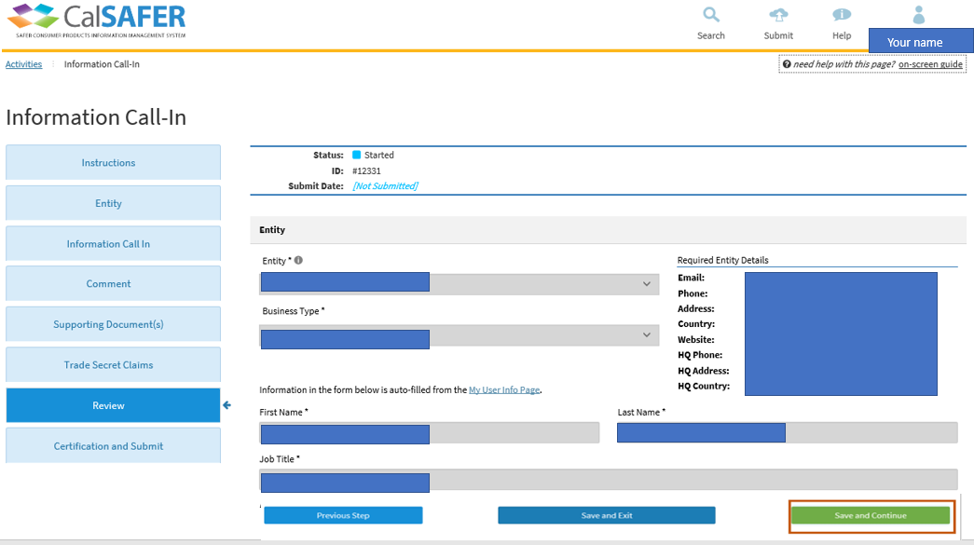

Step Eight – Certification and Submit
The Certification and Submit Step is the last step of the Information Call-In Workflow. To submit your information to the call-in, follow the steps below:
1. Read the “DTSC’s privacy and terms of use” by clicking on the link (see image below).
2. Click the “Yes, I agree to the DTSC’s privacy and terms of use” checkbox (see image below).
You cannot submit to an information call-in, if you do not agree to “DTSC’s privacy and terms of use”. You may choose to “Save and Exit” at this step. If you choose to do so, this will not complete your submittal to a call-in.
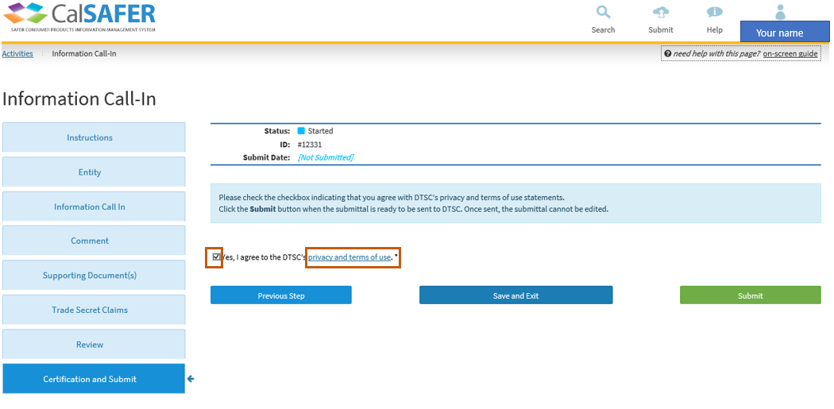
3. Click on the green “Submit” button to submit information to the call-in (see image below).
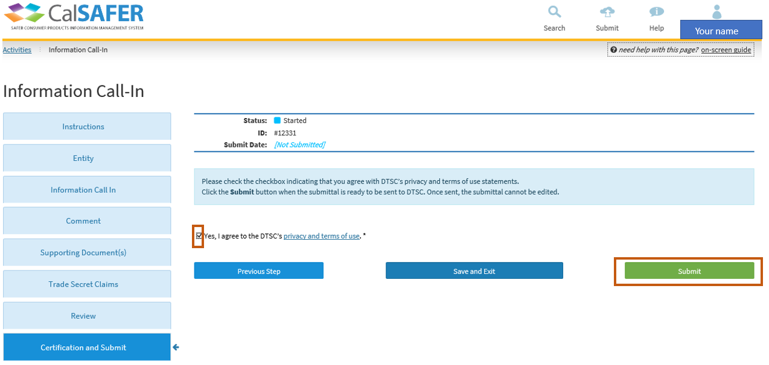
4. Once you click on the “Submit” button, the following message will pop-up stating: “By clicking “Yes” this will be sent to the Department of Toxic Substances Control for review and you will no longer be able to make any further changes” (see image below).
5. If you do not want to make further changes to your submittal, click “Yes” on the pop- up window to submit to the information call-in (see image below). Once you click “Yes”, you will no longer be able to make any further changes to your submittal.
To make further changes to your submittal, click “No” and make the necessary changes and repeat the steps described above to submit when ready.
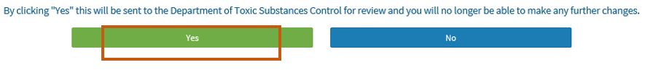
6. Clicking “Yes” button at the pop-up window will complete the submission.
If there is an error or missing information, a notification will pop-up stating that information required for the submission is missing or incomplete under the “Notifications” tab at the top right of the page in red text (see image below).
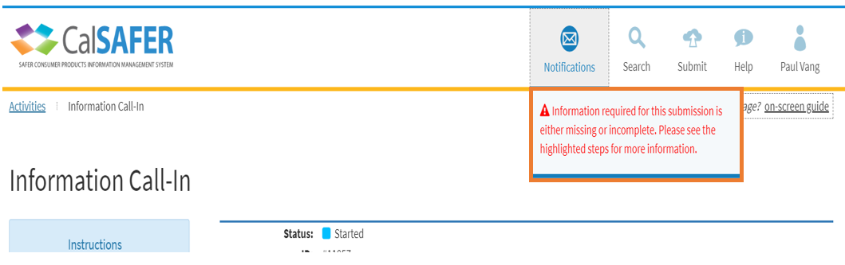

7. If there are no errors, you will see a pop-up window stating that “Your submittal has been successfully sent.” (see image below).
If you click on the “Back to Activities” button, it will bring up the “Activities” window and under the “Information Call-in” at the “Activities” page you can see a record of your submittal to the information call-in. However, at this stage you cannot make changes to your submittal (see image below).
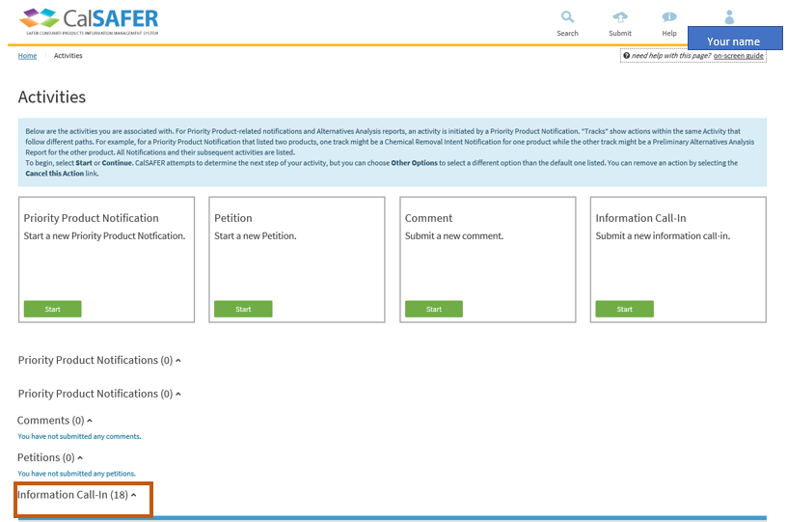

8. After you submit your response to an information call-in, you should receive an email message from CalSAFER stating that your submission has been received. Check your email to confirm (see image below).
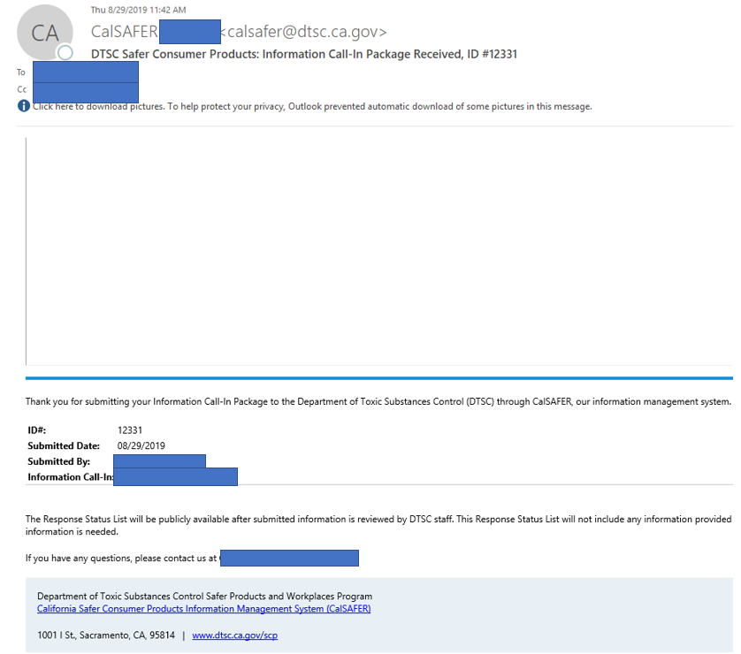

9. If you have any questions about the information call-in or about your submittal, contact DTSC at CalSAFER@dtsc.ca.gov (DTSC contact email address is also provided in the confirmation email of your submittal).

DTSC’s Privacy Policy and Terms Of Use
A copy of the “DTSC’s Privacy Policy and Terms of Use” is presented below:
